**Los Angeles Continuum of Care**

**Homeless Count Methodology Report Summary**

Estimating the number of homeless people in Los Angeles is a difficult task due to the transient nature and varying circumstances of the population. For example, the methods used to count sheltered homeless people may not be appropriate when trying to estimate the number of homeless youth. It becomes even more difficult to estimate the demographics of the population, as relevant demographic information is often not readily available and difficult to obtain for the entire homeless population.

LAHSA (the Los Angeles Homeless Services Authority) and USC collaborated to develop the 2017 homeless count methodology, and have documented the estimation techniques and assumption in a full report, available in this repository. Below are some highlights of the report so you better understand how the LAHSA homeless count data you’ll be working with was generated.

***Homeless Street Point-in-Time (PIT) Count***

95% of census tracts in LAHSA’s jurisdiction were randomly sampled to do the count. 100% of census tracts in Skid Row and Venice were counted as well. Here is the breakdown of census tracts counted by LAHSA’s Service Planning Area (SPA).

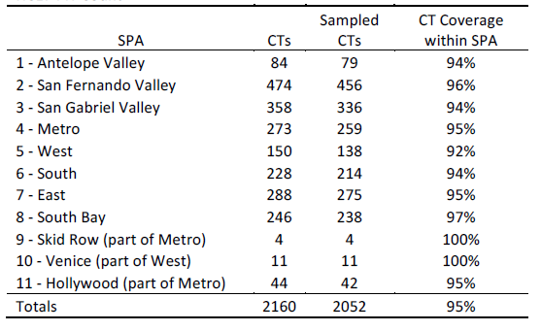

***Demographic Survey of Unsheltered Homeless***

Surveys were conducted in all tracts within Skid Row and Venice, plus additional randomly selected census tracts, for a total of 415 included tracts. All census tracts were separated into four strata (Individual Hot Spot, Family Hot Spot, Vehicle Hot Spot, Non Hotspot). Weights for each type of census tract were developed by taking the inverse probability of selection based on the strata it belonged to. For instance, if 1/2 of Individual Hot Spots were selected for the survey, counts for this sample would be weighted x2.

Unfortunately, surveyors were unable to interview homeless people in a significant number of census tracts. The group did a post hoc adjustment by going into tracts that were not in the sample to conduct interview, leading to the sample not being completely random.

4,808 eligible surveys were collected this year. The data was scaled up based on the PIT count to provide total population estimates for different demographic groups.

***Youth Count***

The youth population is a lot harder to estimate because they may not appear homeless or may be located in inconspicuous areas.

20% of census tracts were sampled. Census tracts were designated as hotspots based on the number of resources in the tract or if it the tract was designated a hotspot by a homeless youth focus group. Census tracts with a previous history of youth counts were also given priority. Like the demographic survey, weights for each type of census tract were developed by taking the inverse probability of selection based on the strata it belonged to.

Refer to the Youth Count Extrapolation Methodology - Visual Explanation document in the repository for more information.

***Shelter Count***

The sheltered population was a 100% enumeration of all homeless people within a shelter. Demographic information was estimated from the Homeless Management Information System (HMIS).